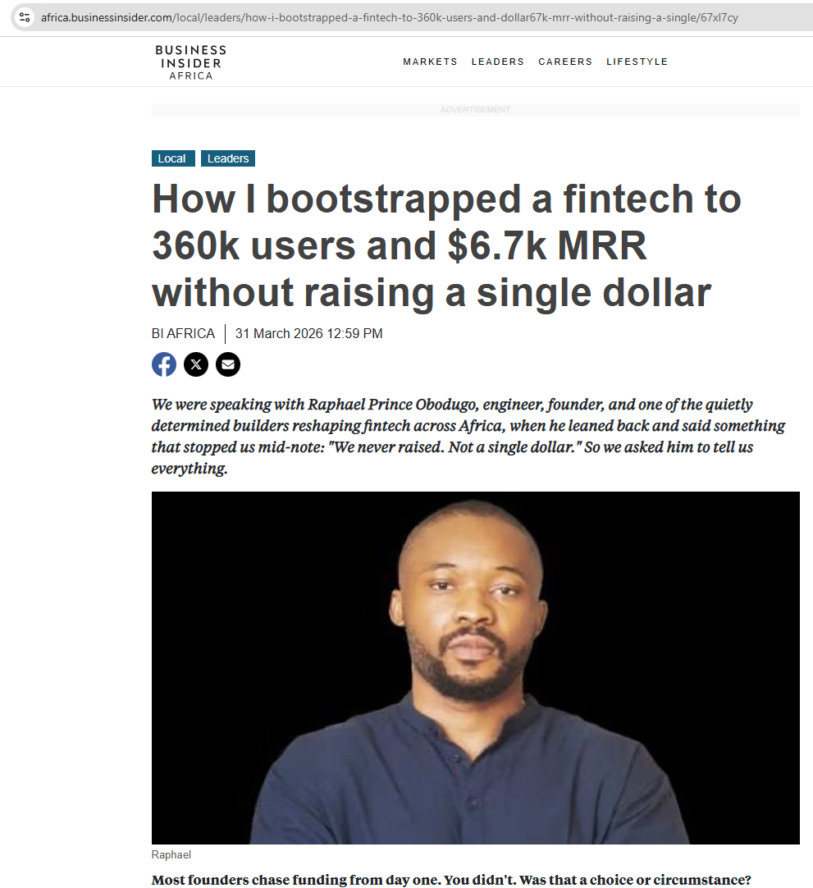

https://africa.businessinsider.com/local/leaders/how-i-bootstrapped-a-fintech-to-360k-users-and-dollar67k-mrr-without-raising-a-single/67xl7cy



